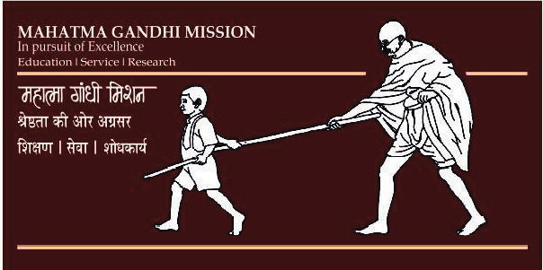RNI: MAHENG/2016/68030

Vol. 2 No. 1 January-February (2017): Page No. 1-7

# **VISTA INTERNATIONAL JOURNAL**

MGM’s JAWAHARLAL NEHRU ENGINEERING COLLEGE

# **ON ENERGY, ENVIRONMENT & ENGINEERING**

**ISSN: 24565342 (print)**

**Development of an experimental method to determine the natural frequency of an engine.**

Priyank Metha1* and Rohit Salgaonkar2

1,2, K. J. Somaiya College of Engineering, Mumbai

Vidyanagar, Vidya Vihar East, Mumbai, Maharashtra 400077, Maharashtra, INDIA

**\*Corresponding author:** [methapriyank@gmail.com,](mailto:methapriyank@gmail.com,%20) Tel: +91-9870020238

A B S T R A C T

The braking system in automobile is of vital importance from safety point of view.Abrake is a device by means of which the frictional resistance is applied to moving machine member in order to stop its motion. While performing this function, the brakes absorb kinetic energy of the moving member and convert it into heat energy, which is dissipated to the surrounding atmosphere.The objective of this paper is to study and analyze the induced stresses and the total deformation in the disc brake rotor for various identified disc design configurations, to obtain a best suitable design having maximum heat dissipation and reduced weight. For the study, the 3D models of disc brake rotors are created using the modeling software Creo 3.0 where the inner and outer diameter, the mounting positions for wheel and the disc material of the existing brake disc rotor of a two wheeler vehicle is kept constant. Temperature, pressure and the moment are used as the input parameters at its maximum permissible values for the analysis. The best suitable design is found using finite element analysis with the help of ANSYS multiphysics software. The modal analysis is performed later to verify the natural and forced frequencies of obtained best disc brake rotor with the existing model of disc brake rotor.

*Keywords: Disc brake rotor, equivalent Von-Mises stress, existing and modified disc, total deformation, total heat flux.*

1. Introduction

The automotive brake is basically a mechanical device which inhibits motion to make slow or stop a moving object.When brakes are applied, hydraulically actuated pistons move the friction pads in to contact with the disc, applying equal and opposite forces on the later. Upon releasing the brakes, the rubber-sealing ring acts as return spring and retracts the pistons and the friction pads away from the disc (Fig. 1).

In this work, the existing model of the Bajaj Pulsar 150 brake disc rotor is compared with several new self- designed disc brake rotors. The inner and outer diameter, mounting positions for wheel and disc material are kept constant and the design pattern of petals and the vent holes are changed. The CAD models for the disc brake rotors are created in Creo3.0 and the further analysis work is done in ANSYS 15.0

In the thermomechanical behavior of the dry contact between the brake disc & pads during the braking phase, the temperature field and stress field in the process of braking phase are fully coupled [1]. The contact pressure can be predicted, higher at the leading side compared to

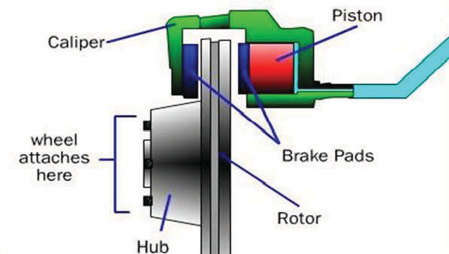

Fig. 1. Working principle of disc brake

the trailing side and its value slightly increases with the increase of disc rotation speeds during single braking stop event by employing commercial FE software [2].The heat generated due to friction between the disc & pad should be ideallydissipated to the environment to avoid decreasing the friction coefficient between disc and the pad [3].Due to decrease in heat generation ratio, conduction in the disc and convection on the surface of brake disc, temperature field presents approximately axisymmetric in the end stage of the braking operation [4].The thermal performance of a disc brake at a reduced scale by proposing the scaling methodology results in concluding that the scaling methodology can be used with confidence for the design & development of automotive disc brake systems [5]. The real part of the domain unstable eigenvalue is reduced effectively & the constraint reliability satisfies the design requirement well at the optimal values of the design parameters [6]. The cracks observed on the friction surface of the brake discs are originated by thermal fatigue due to the local recidual stress produced during brake application [7].Evaluation of rotating speed of disc and contact pressure with specific material properties intensely effect disc brake temperature fields in the domain of time [8].The stainless steel can provide better brake performance than others from deformation point of view & CI provides better performance from stress point of view [9]. Ventilated type maraging steel disc brake is the best possible for the present application [10].

Materials having lower value of the modulus of elasticity and higher value of density have lower values of natural frequencies [11]. It is common to use finite element method (FEM) to perform this analysis and the results are acceptable [12, 13] .

|  |  |  |  |
| --- | --- | --- | --- |
| Properties | Values | Properties | Values |
| Density (Kg/m³) | 7800 | Poisson’s Ratio | 0.152 |
| Coefficient of thermal  expansion | 1.3x10-5 | Bulk Modulus  (GPa) | 95785 |
| Young’s Modulus (GPa) | 200 | Shear Modulus  (GPa) | 86806 |

In this work, the existing model of the Bujaj Pulsar 150 brake disc rotor is compared with several new self-designed disc brake rotors. The inner and outer diameter, mounting positions for wheel and disc material are kept constant and the design pattern of petals and the vent holes are changed. The CAD models for the disc brake rotors are created in Creo3.0 and the further analysis work is done in ANSYS workbench 15.0.

Modal analysis is used to determine the natural mode shapes and frequencies of the existing disc and to comparatively analyze with frequencies of the obtained best modified disc designs during free vibrations as well as in prestress condition.

1. Disc design parameters

The original dimensions of disc brake rotor like outer diameter, inner diameter and mounting hole positions are kept constant for the new modified rotor discs so as to maintain its suitability to fit.

The basic and constant disc design parameters obtained from the existing model of disc brake rotor are given in Table 1.

Table 1. Disc Design Parameters

|  |  |
| --- | --- |
| Parameters | Values |
| Disc Outer Diam. (mm) | 240 |
| Disc Inner Diam. (mm) | 110 |
| Disc Thickness (mm) | 4 |

1. Material properties

The disc material used for the Bajaj pulsar 150 existing brake disc rotor is the SS410. Same material is used for all the modified discs [9]. The material properties of SS410 are given in Table 2.

Table 2. Material Properties

1. Methodology
   1. Modeling in Creo 3.0: Creo software is the standard in the 3D product design, featuring industry-leading productivity tools that promote one of the best practices in design while ensuring compliance regarding industryand company standards. It allows you to design faster than any other software. The figure shows the solid model of the disc brake by using Creo 3.0 (Fig 2).

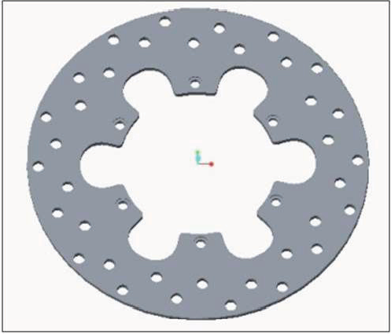

Fig. 2. Creo model of Existing Pulsar 150 brake disc rotor

Similarly; the CAD model for the modified discs is prepared as shown in Fig 3.

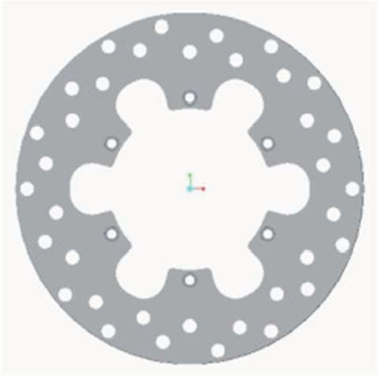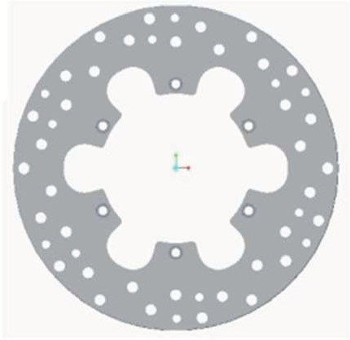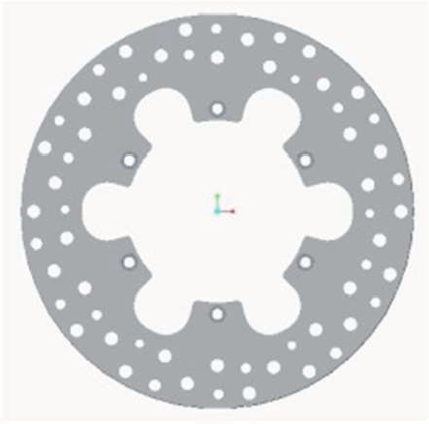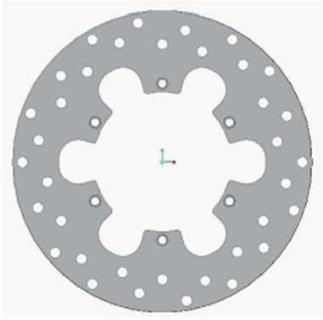

Fig. 3. Creo models of modified discs

Fordisc 1, the modification made in the vent holes of the disc i.e. diameter increased by 1.5mm. For the disc 2, a few no of vent holes with 6mm diameter are added in existing disc pattern. Disc 3 is the modification in disc 2 with some more no of vent holes increased. The disc 4 is the modification in existing disc model with the thickness reduced by 0.5mm.

* 1. Analysis in ANSYS :

The ANSYS software implements the equations that govern the behavior of the meshed elements and solve the problems, by creating comprehensive description of how they act as a whole. The results can be obtained in the form of tabular column or graphical forms. Here ANSYS Workbench 15.0 is used for the analysis work.

* + 1. Meshing:

For analysis the disc brake was meshed using tetrahedron type elements. The number of nodes and elements for each disc is given in Table 3.

Table 3. No. of elements and nodes for the discs

|  |  |  |
| --- | --- | --- |
| Disc Existing | No of Elements | No of Nodes |
| Disc | 226244 | 352594 |
| Disc 1 | 220080 | 344284 |
| Disc 2 | 225489 | 352968 |
| Disc 3 | 222807 | 349752 |
| Disc 4 | 200089 | 318884 |

The figure below (Fig. 4) shows the meshed model for the existing disc. The size of element for meshing in area of disc and pad interface is kept as 1.5mm and for the rest part it is 2.5mm for all the discs.

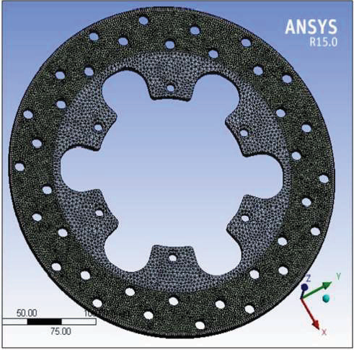

Fig. 4. Meshed model of existing brake disc

* + 1. Coupled static structural analysis:

The steady state thermal analysis determines the temperature distribution and other thermal quantities under steady state loading conditions. A steady state loading condition is a situation where heat storage effects varying over a period of time can be ignored. (Fig.5)

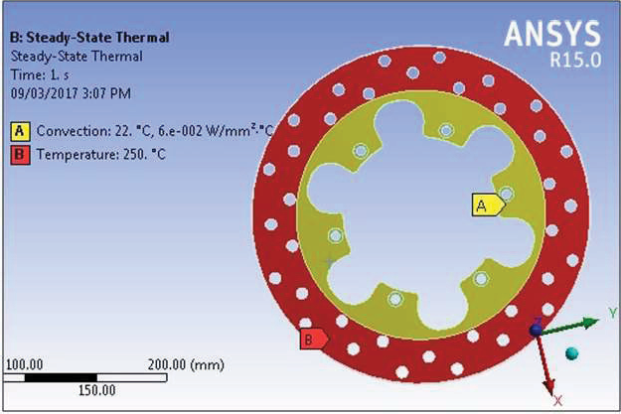

Fig. 5. Steady state thermal analysis boundary conditions

Static structural analysis calculates the effects of steady loading conditions on a structure, while ignoring inertia and damping effects such as those caused by time varying loads. A static analysis can, however include steady inertia loads such as gravity and rotational velocity.(Fig. 6)

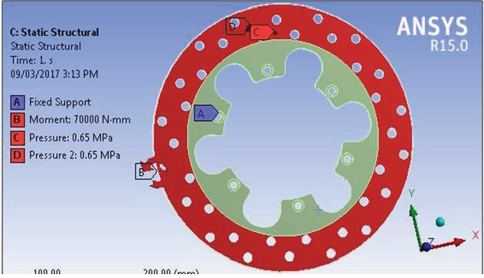

Fig. 6. Static structural analysis boundary conditions

The previous Thermal conditions and results are imported in the structural analysis and the combined results are obtained when thermal analysis is coupled.

* 1. Results and comparison:

The Equivalent Von-Mises Stress, Total Heat Flux and Total Deformation analysis results for existing disc are as shown in figures (Figs. 7- 9).

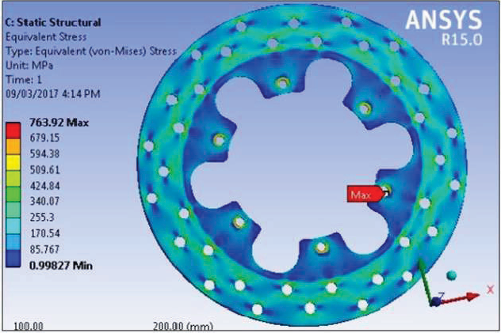

Fig.7. Stress Distribution in existing disc

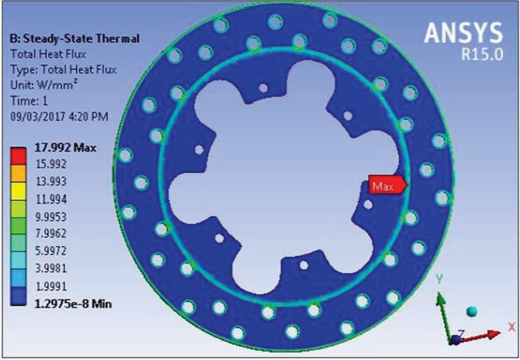

Fig.8. Total Heat Flux in existing dis

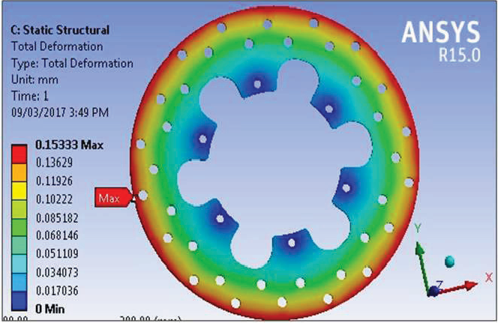

Fig.9. Total Deformation in existing disc

Similarly the analysis results for equivalent Von-Mises stress, total heat flux and total deformation as well as the weight of each disc are obtained for all the modified discs (Table 4).

Table 4. FEA Results for all the modified discs

Mode Natural

Natural

Forced

Forced

frequencies frequencies frequencies frequencies

of Existing of Disc 3 of Existing of Disc 3 Disc Disc

Parameters Equivalent Total

Von-Mises Heat

Total

Defor- Weight

Discs

Stress

(Mpa)

Flux

mation

(g)

(W/mm²) (mm)

|  |  |  |  |  |
| --- | --- | --- | --- | --- |
| Existing |  | | | |
| Disc | 763.92 | 17.992 | 0.153 | 887.45 |
| Disc 1 | 756.94 | 18.798 | 0.143 | 864.16 |
| Disc 2 | 792.57 | 20.508 | 0.133 | 876.73 |
| Disc 3 | 812.12 | 26.976 | 0.110 | 838.99 |
| Disc 4 | 979.28 | 24.62 | 0.178 | 755.01 |

1. Modal analysis :

|  |  |  |  |  |
| --- | --- | --- | --- | --- |
| 1 | 640.57 | 670.03 | 688.99 | 712.84 |
| 2 | 661.87 | 683.04 | 689.82 | 713.61 |
| 3 | 662.61 | 684.12 | 694.93 | 716.94 |
| 4 | 758.97 | 758.11 | 722.64 | 717.69 |
| 5 | 759.96 | 758.86 | 723.28 | 722.2 |
| 6 | 931.02 | 903.94 | 743.44 | 768.97 |
| 7 | 1140.8 | 1119.2 | 991.89 | 1038.9 |
| 8 | 1520.4 | 1475.6 | 1267.9 | 1334.8 |
| 9 | 1520.8 | 1476.1 | 1268.5 | 1335.4 |
| 10 | 2184.6 | 2118.1 | 1890.6 | 1955.7 |

It is a form of vibration testing of an object where the natural (modal) frequencies, modal masses, modal damping ratios and mode shapes of the object under test are determined. The impact hammer testing and shaker (vibration tester) testing are the common ways to do modal testing experimentally. In the EMA, where structural resonances occur there will be an amplification of the response, which will be seen clearly in response spectra. It is common to use FEM to perform this analysis and the results are acceptable.

From the thermomechanical analysis of the existing as well as the modified discs, it is observed that modified disc 3 has the most significant values. Hence, the modal analysis is carried out for the existing and modified disc 3 to determine its natural and forced frequencies for 10 number of modes as shown in Table 5.

1. RESULT AND DISCUSSION

The results obtained for the equivalent stress, total heat flux, and total deformation are shown in the graphical form in Fig 10.

Table 5. Natural and forced frequencies of existing and modified disc 3.

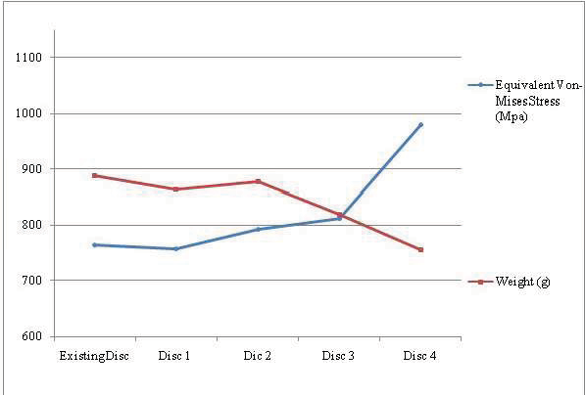

Fig. 10. Graphical representation of obtained Equivalent Von-Mises stress and weight for all the discs

Figure 10 shows that disc 3 has the most significant values as compared to that of equivalent stress and weight of the existing disc.

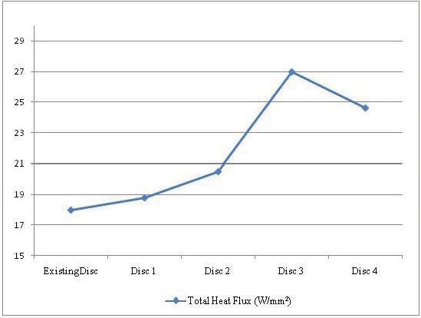 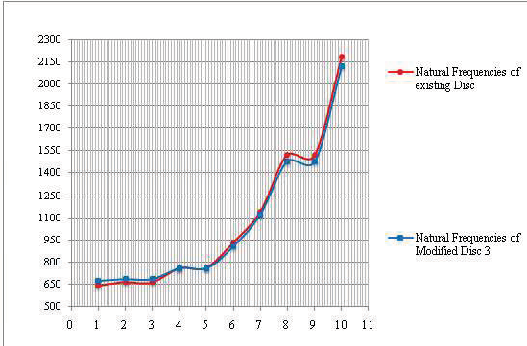

Fig. 11. Graphical representation of total heat flux for all the discs

Figure 11 shows that the value of heat flux obtained is increased maximum for the modified disc 3 which shows the maximum heat dissipation.

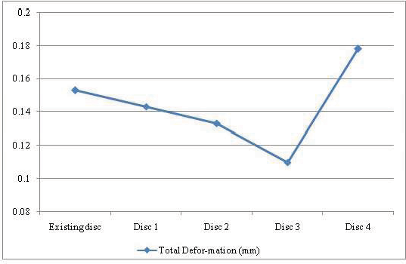

Fig. 12. Graphical representation of total deformation obtained for all the discs

Figure 12 shows that the maximum deformation for modified disc 3 has the minimum value as compared to that of the existing disc.

The graphical representation of natural and forced frequenciesrespectively of existing and modified disc 3 is shown in Figs 13 and 14 respectively. It is observed that the values are closely related with the average difference of 4.59% for natural frequencies and 3.46% for forced frequencies

Fig. 13. Graphical representation of natural frequencies of existing and modified disc 3

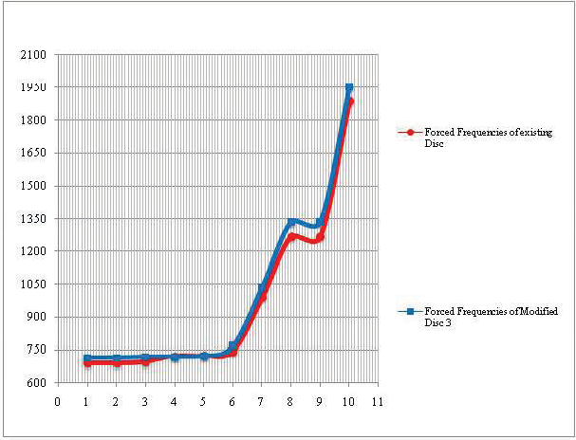

Fig. 14. Forced frequencies of existing and modified Disc 3

1. Conclusion

Disc profile plays important role in thermal distribution and hence should be selected carefully. The conclusions for this work can be summarized as below:

1. The induced stresses, heat dissipation (total heat flux) and total deformation in the disc brake rotor are analyzed for the maximum permissible boundaryconditions for better disc design configurations.
2. The best suitable design (modified disc 3) having maximum heat dissipation and minimum deformation is

VISTA INTERNATIONAL JOURNAL ON ENERGY, ENVIRONMENT& ENGINEERING Vol.2 No.1 Jan-Feb (2017) I 7

obtained using ANSYS simulation. The stress generated is slightly increased for the obtained best disc design but is acceptable value, percentage increase is 6.03%.

1. By modifying the design of the existing disc brake rotor of vehicle Bajaj Pulsar 150, the weight of the rotors is also reduced by 48.46g (i.e. 5.46%).
2. The results of modal analysis shows there is no any adverse effect of design modification on disc profile and its performance, in fact it has a very positive impact.

Hence, the results are improved for modified disc 3 as compared to the existing disc and other profiles.

References

1. Ali Belhocine, MostefaBouchetara, Thermal– mechanical coupled analysis of a brake disk rotor, (Springer-US)*Heat and mass transfer,* 49(8), 2013, pp. 1167–1179.
2. Abd RahimAbu Bakar,Ali Belhocine, OdayIbraheem Abdullah, Structural and Contact Analysis of Disc Brake Assembly During Single Stop Braking Event, (Springer-India) *Transactions of the Indian Institute of Metals*,*68*(3), 2014, pp. 403-410.
3. FaramarzTalati, Salman Jalalifar, Analysis of heat conduction in a disk brake system, (Springer-Verlag) *Heat Mass Transfer,* 45(8),2009, pp.1047-1059.
4. Pyung Hwang, Xuan Wu, Investigation of temperature and thermal stress in ventilated disc brake based on 3D thermo-mechanical coupling model, (Springer- Korea) *Journal of Mechanical Science and Technology,* 24(1), 2010, pp. 81–84*.*
5. Alnaqi, Abdulwahab A., Barton, David C., Brooks Peter C, Reduced scale thermal characterization of automotive disc brake, (Elsevier) *Applied Thermal Engineering,* 75, 2015, pp. 658-668.
6. Hui Lu, Dejie Yu., Optimization design of a disc brake system with hybrid uncertainties, (Elsevier) *Advances in Engineering Software,* 98, 2016, pp. 112–122.
7. F. Bagnoli, F. Dolce, M. Bernabei, Thermal fatigue cracks of fire fighting vehicles gray iron brake discs, (Elsevier) *Engineering Failure Analysis*, 16(1), 2009, pp. 152–163.
8. PiotrGrze, Finite element analysis of disc temperature during braking process, *Acta MechanicaetAutomatica*, 3(4), 2009.
9. VirajParab, KunalNaik, Prof A. D. Dhale, Structural and thermal analysis of brake disc, *International Journal of Engineering Development and Research*, 2(2), 2014, pp. 1398-1403.
10. V. Chengal Reddy, M. Gunasekhar Reddy , Dr. G. HarinathGowd, Modeling and analysis of FSAE car disc brake using FEM, *International Journal of Emerging Technology and Advanced Engineering*, 3(9), 2013, pp. 383-389.
11. Nilesh K.Kharate , Dr. Sharad S.Chaudhari, Investigation of Natural Frequencyand ModalAnalysis of Brake Rotor Using Fea and Ema, *International Journal of Innovative Research in Science, Engineering and Technology*, 3(10), 2014, pp. 16495-16500.
12. Mr. Pravin N. Jawarikar, Dr. Subim N. Khan, Mr. Balaji D. Kshirsagar, structural optimization, thermal and vibration analysis of two wheeler disc brake rotor, *International Conference on Recent Innovations in Engineering*, *Science, Humanities and Management,* Rushikonda, Vishakhapatnam,pp. 336-353.
13. Mahmood Hasan Dakhil,A. K. Rai, P. Ravinder Reddy, Ahmed Abdulhussein Jabbar, *Design and structural analysis of disc brake in automobiles*, 4(1), 2014, pp. 95-112.